**Installation Guides**

## **Pre-Installation Requirements**

The following prerequisites and requirements must be satisfied in order to install successfully.

### **Database Prerequisites**

Identify the server prerequisites, such as:

* PostgreSQL 10.5.2:

### **Software Prerequisites**

Identify software prerequisites, such as:

* WildFly 13.0.0 Final

### **Other Installation Requirements**

The following installation requirements must also be completed:

* Run the sql scripts in “employee” database by this order.

1. createTable_2019_08_05.sql
2. updateTable_2019_08_13.sql
3. initial_data_2019_08_05.sql

## **Link of Servers**

1. Access the Jenkin

<http://192.168.70.59:9999/job/employee-core(Dev)/> - for employee-core module

<http://192.168.70.59:9999/job/employee-ui(Dev)/> - for employee-ui module

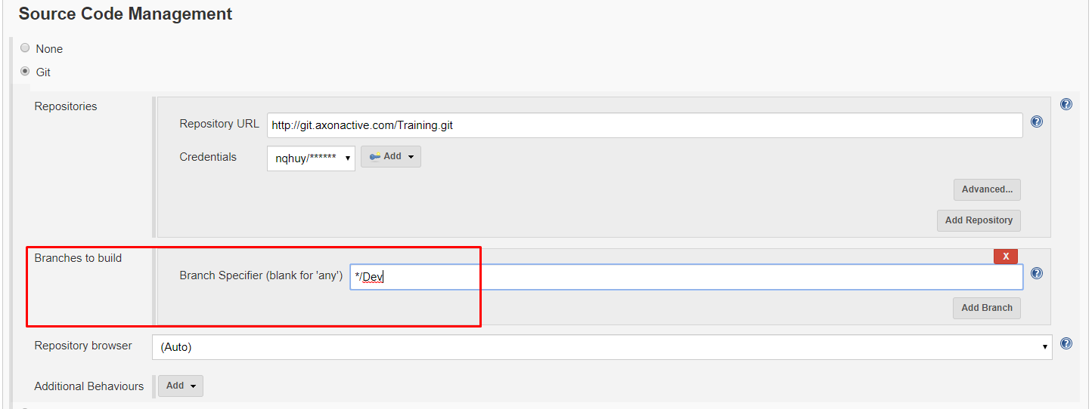

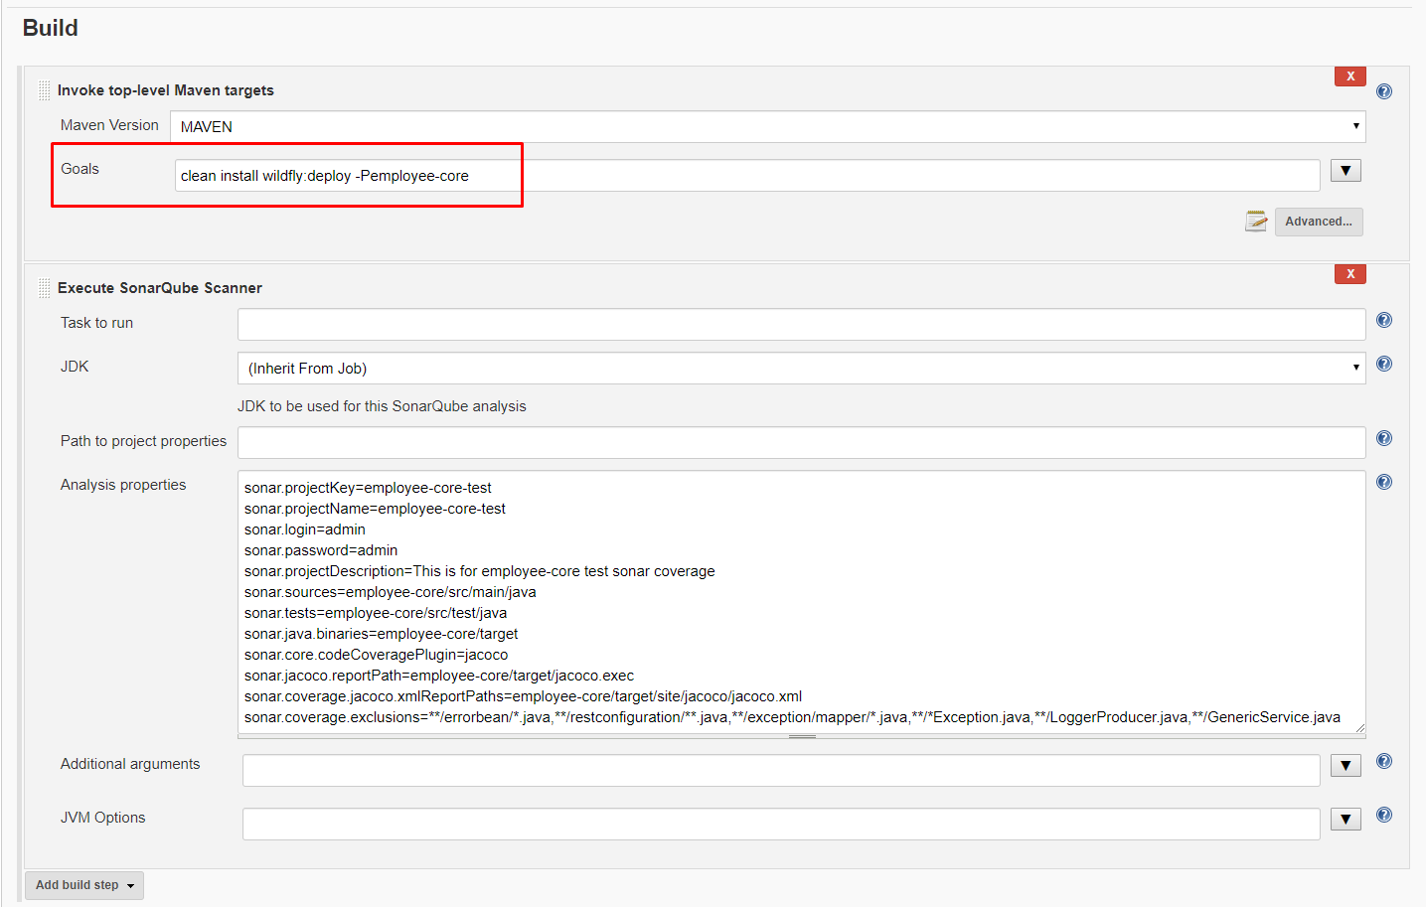

* check configure of git branch and maven build goal carefully before build the project